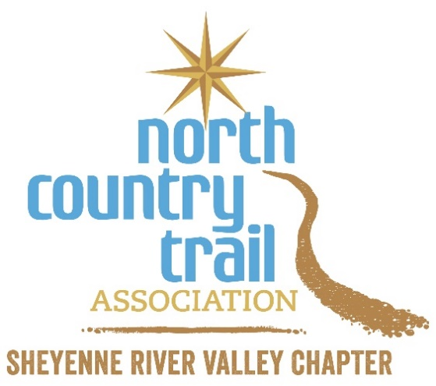
Registration Form

Name: ______________________________________________________________________
Email address: ________________________________________________________________

Phone: _______________________________________________________ Cell? Yes No

Are you an existing NCTA - SRV Chapter or At-large member? Yes No

If not, would you like to join our email list to be notified of upcoming Chapter activities?
Yes No

Are you interested in receiving more information about volunteer opportunities? Yes No

****

Email the completed form ASAP to srv@northcountrytrail.org to register and be added to the SRV Chapter’s email list for hikes and workdays (unless you opted out above).
If you have questions or would like more information, contact Matthew Davis at (701) 388-1883 / mdavis@northcountrytrail.org or the SRV Chapter at srv@northcountrytrail.org.

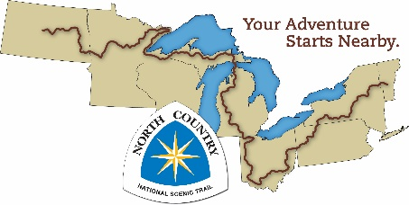

Date: 8/4/22

