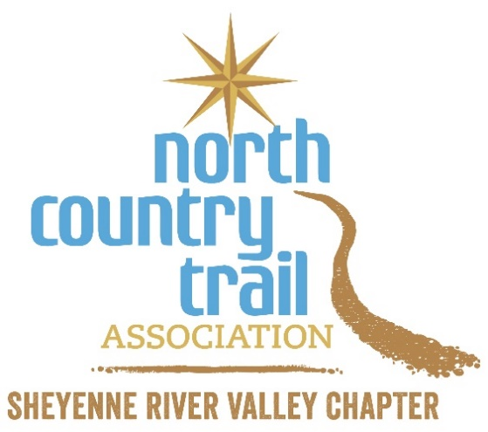
SRV Challenge Log Form
Save this form to track your progress. Points accrue from January 1, 2024 to December 31, 2024. Remember you have until January 15, 2025 to submit your final points.
Earn points with these engagement opportunities | Completed? | Date completed | Points earned
Earn your first 25 points by emailing your completed registration form to us. Must register before accruing points! | Yes  No
Earn 100 points by joining the NCTA - SRV Chapter (northcountrytrail.org/join-renew). VCSU Students - contact the SRV Chapter about discounted membership opportunities. | Yes  No
Earn 100 points by attending a SRV Chapter workday (northcountrytrail.org/files/chapters/srv/2024%20SRV%20Events%20Calendar.pdf) Earn 250 points by attending a second SRV Chapter workday! | Yes  No
Earn 50 points by volunteering for at least an hour at a SRV Chapter outreach event in the local community. | Yes  No
Earn 500 points by adopting an approved off-road segment of the NCT to maintain for a year! Must first become a member and complete VIP agreement. | Yes  No | Which section did you adopt?
Earn 75 points for completing the Trail Maintenance or Trail Adopter training. | Yes  No
Earn 25 points by joining a Chapter guided hike or event. | Yes  No
Earn 10 points for inviting a friend to join a NCT hike or for sharing a social media post about NCT or by sharing a NCTA post [tag @NCTinND]. | Yes  No | For the hike, who went with you and where did you go?
Earn 1 point per mile for hiking on your own [record your mileage on the Hike 100 log form] | Yes  No | Where did you go hiking on the NCT?
Earn 25 bonus points by completing the NCTA’s Hike 100 Challenge (see northcountrytrail.org/hike-100-challenge). | Yes  No | When did you finish?
Earn 100 bonus points by completing the Dakota Challenge and hiking 475 miles across North Dakota along the NCNST. | Yes  No | When did you finish?
How many points did you accrue?

Reminders: You need 200+ points to be eligible for the prize drawing in January 2025. You need to return your form by email to us by January 15, 2025.

Email the completed form to srv@northcountrytrail.org.

Date: 1/1/24

