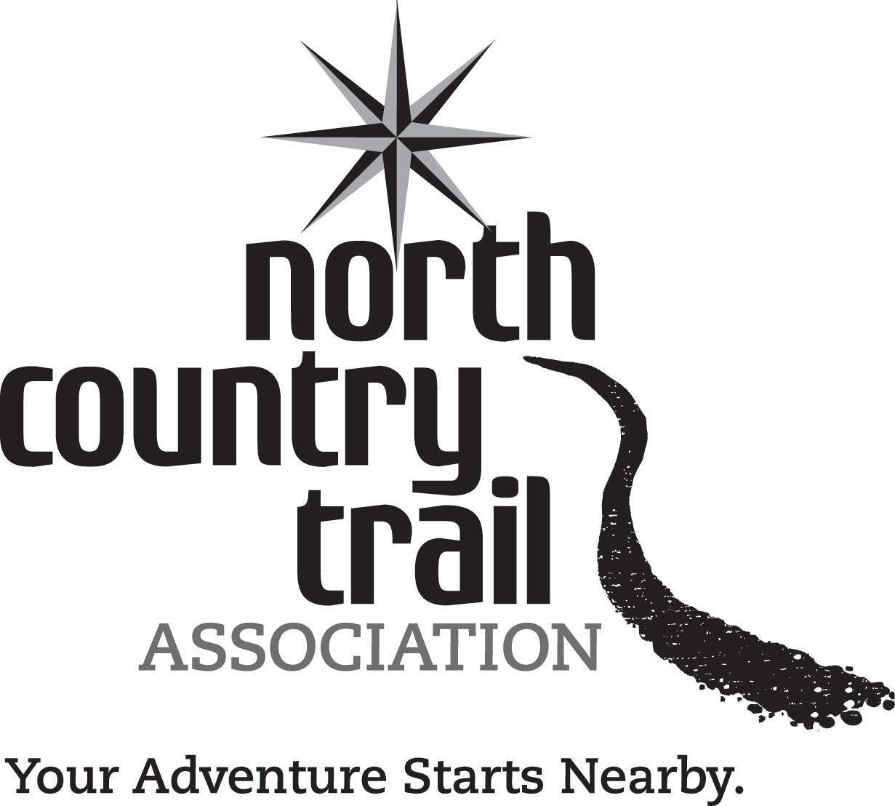
Field Grant Guidelines

The North Country Trail Association offers Field Grants in the amounts of $200 - $5000 to Chapters, Affiliates, Regional Trail Coordinators, and Trail Councils. Applications are received and reviewed four times each year by the Field Grant Committee and awarded on a competitive basis according to benefits to the Trail and the Association, need of the applicant, and the applicant’s grant history.
To apply for a Field Grant, fill out the application form and email, fax or mail to the NCTA office.
- Ensure you have two names on the application. The Chapter, Affiliate, or State entity signature must be different than the applicant’s name.
- Your application must be received in the office by the deadlines shown below to be considered during the respective grant cycles.
- Applications to fund the construction of trail or facilities must include a letter or email communication from the landowner or land manager (on public lands) stating that they are aware of and grant permission for the project as described in the application. See question #3 for more detail.
- All projects must include an estimate for volunteer hours in the Budget section of the application. See question #9 below.

- The following types of projects exemplify those that will be considered (“trail” refers to designated North Country National Scenic Trail or its planned route, connector or side route).
- Special events, programs, or projects to build public support of the trail or membership in the NCTA.
- Installation or repair of the trail, trail facilities, or trail signage or displays.
- Purchase of major tools or equipment for work related to the trail.
- Volunteer training events.
- Requests for general operational support. However, requests to fund newsletters or other routine activities normally covered by dues sharing are discouraged.
- Other related projects also may be considered.

- Grant decisions will be made four times per year. Because Field Grants funds are competitive, your application may not receive immediate funding. If you do not receive funding, you may request that the Committee keep your application on file to consider again in the following grant cycle. Or, if you wish, you also may resubmit the application with changes or improvements. Grant cycles are as follows:

Grant cycle | Application deadline | Award notification
Late Winter  Spring  Summer  Fall | February 1  April 15  July 15  October 15 | March 1  May 15  August 15  November 15

- Awards will not be transferred directly into your Chapter’s/Affiliate’s account but will be managed in a separate account maintained by NCTA with disbursement to be in accordance with NCTA accounting procedures.
- Field Grant projects for which an award hereunder is made should be completed within one year of the grant award or one (1) year of the scheduled commencement date as contained in the Grant Application, whichever is later. In general, new grants will not be awarded if a previous Field Grant project has not been completed. Field Grant projects are not considered complete until a Final Report Form has been filed. (Grants for general operational support are considered “complete” as soon as the grant is awarded.) Unused funds associated with the project will be transferred back to the Field Grant account.

Field Grant Application Form
Please answer all of the questions below. The information presented should give the Field Grant Committee an understanding of your proposed project/request, how it benefits the Trail and the Association and why Field Grants should fund it. Supplemental materials such as structure drawings, material quotes and letters of support are welcome. Only complete applications will be accepted.

1) Applicant: Date:
(Chapter, Affiliate, RTC or Council)

To demonstrate agreement and support for your request, you must have two signatories on this application, both representing the applicant (e.g. Two Chapter/Affiliate Officers). In lieu of a signature, an email will suffice.

2) Signatures:

Representative Signature

Additional representative Signature

3) Type of Project (check the one that best describes the main purpose of your request):
Construction Project: In order for a construction project to be considered for funding, you must include along with your application written permission from the land manager or landowner. Either submit the documentation with your application, or have the land manager or landowner send a note verifying that he or she has seen the application and has approved the project. Applications to fund construction projects will not be considered if this written approval has not been received by the grant deadline. Note: a drawing plan or sketch (including dimensions) of the proposed structure(s) must be included with this application, and reviewed with the landowner/manager prior to their sign-off.
❑ Trail Sign or Display ❑ Trail Construction ❑ Trail Facility (bridge, campsite, shelter, barrier, etc.)
Has this project been submitted to the National Park Service’s compliance review process?
❑ Yes ❑ No ❑ Does not apply
If yes; what is the status of that submission? (approved, pending, unsure, etc.)
_____________________________________________

Non-Construction Request:
❑ Promotion or Recruitment ❑ Volunteer Training ❑ Trail Maintenance ❑ Public Event
❑ Equipment ❑ Other:_____________________________________________
❑ $300 grant to assist with various operational expenses. (Only for Chapters with an account balance of less than $400. You will not be awarded more than one of these grants per year. For these grants, you may skip question #6, and are not required to submit a Final Report.)
4) Name of Project: _____________________________________ Amount Requested: $

5) Project Location:

6) Please describe your project or request. Include project details and proposed timeline.

7) How would this grant benefit the North Country National Scenic Trail and the North Country Trail Association? Describe the critical need(s) addressed by this project. What is the problem and how will this project be a solution? As appropriate, provide quantitative measures that will indicate success (e.g. # of people trained, copies of publications distributed, miles of trail built or acres of land protected, etc.). (Attach additional sheets as necessary.)

8) Is the applicant financially able to undertake this project in whole or in part from its own financial resources? List and describe other efforts that the applicant has made or is making to secure other funding for the proposed project.

9) Please use the table below to present the budget and supply needs for project.
Use one line for each estimated expense and attach quotes if available. Use the different columns to show matching funds if applicable. If you are purchasing supplies (such as lumber), you can lump them together in the Budget table, but should provide greater detail in the Supplies box.

BUDGET
Type of Expense  Describe each briefly | Field Grant Request | Regular Chapter Funds  Not required | Other  Funds or Donations  Not required | Totals
 | $ | $ | $ | $
 | $ | $ | $ | $
 | $ | $ | $ | $
 | $ | $ | $ | $
 | $ | $ | $ | $
Required  Volunteer Hours (Use $28.54/hr.) |  |  |  | $
Totals for each column: | $ | $ | $ | $

SUPPLIES
Please list any supplies you expect to purchase here, if you have not provided detail in the budget. These can be rough estimates, but your final purchases should be reasonable comparable to what you list here. Don’t bother showing costs here. (For instance: 6 treated 2x4x8’s, 2 treated 2x10x12’s, 1 box 2½” deck screws, etc.)

10) If this grant is not funded during the current grant cycle, do you want the Committee to keep it on file to reconsider in future cycles? (It would be kept on file for up to one year.)
❑ Yes ❑ No

Please submit this application with any supplemental information to vbader@northcountrytrail.org

